Chaddesley Corbett Local History Society
2025 Programme

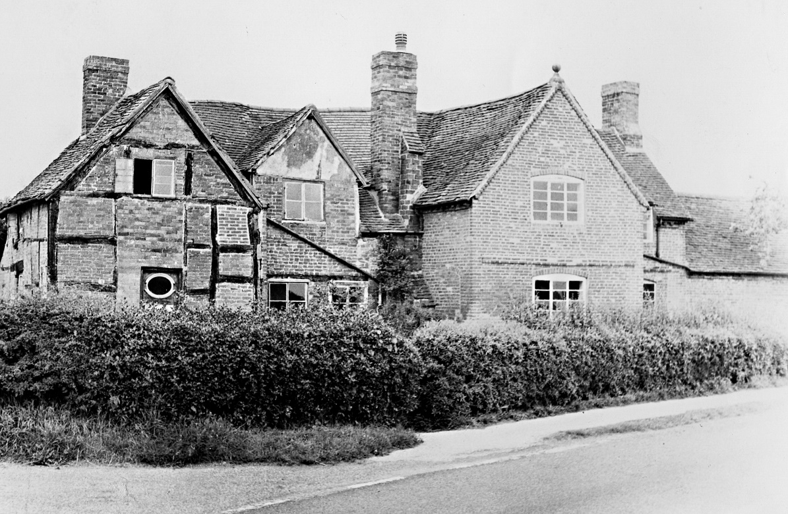
Red Cross Farm

February 19 Great Wall of Kidderminster, Michael Loftus
March 19 (AGM) Bessie Blount of Kinlet, Robert Hodge
April 16 Beyond the Seas, David Clark
May 21 Diary of William Lea, Vanessa Morgan
September 17 King John, Max Keen
October 15 Bourneville Bob Booth
November 19 World War II Christmas, From Time to Time

Talks held on a Wednesday 7.30pm in Chaddesley Corbett Village Hall
DY10 4QA
Enquiries to Freda Griffith 07747618487
Email – fred@fredagriffith.co.uk
Visitors are always welcome @£5 paid on the door.
FIND US ON FACEBOOK Chaddesley Corbett Local History Society
For further updates and to post interesting history notes or enquiries

